AUN-QA
SELF-ASSESSMENT REPORT

PROGRAM NAME

FACULTY NAME,
SRINAKHARINWIROT UNIVERSITY

Month Date , 2024

แบบรับรองความถูกต้องสมบูรณ์ของข้อมูล

ขอรับรองว่าข้อมูลที่นำเสนอในรายงานการประเมินตนเอง ฉบับนี้ ได้มีการดำเนินการจริง
และขอรับรองว่าอาจารย์ประจำหลักสูตร (เกณฑ์มาตรฐานหลักสูตร 2558) /อาจารย์ผู้รับผิดชอบหลักสูตร
(เกณฑ์มาตรฐานหลักสูตร 2558) ได้ประจำหลักสูตร.....................................สาขาวิชา ..............................หลักสูตร (ปรับปรุง/ใหม่) พ.ศ.............................................เพียงหลักสูตรเดียว โดยไม่ได้ประจำหลักสูตรอื่นอีก
(กรณีหลักสูตร...................................................เป็นหลักสูตรพหุวิทยาการ (Multidisciplinary) อาจารย์ประจำหลักสูตร (เกณฑ์มาตรฐานหลักสูตร 2558) /อาจารย์ผู้รับผิดชอบหลักสูตร (เกณฑ์มาตรฐานหลักสูตร 2558) ได้ประจำหลักสูตร...................................... อีก 1 หลักสูตร และอาจารย์ผู้รับผิดชอบซ้ำไม่เกิน 2 คน)

(.................................................................)

ประธานหลักสูตร

( .................................................................) (...............................................................)

หัวหน้าภาควิชา (ถ้ามี) คณบดี

TABLE OF CONTENTS

Page
- INTRODUCTION 4
- AUN-QA CRITERIA AT PROGRAM LEVEL
AUN-QA Criterion 1: Expected Learning Outcomes 00
AUN-QA Criterion 2: Program Structure and Content 00
AUN-QA Criterion 3: Teaching and Learning Approach 00
AUN-QA Criterion 4: Student Assessment 00
AUN-QA Criterion 5: Academic Staff 00
AUN-QA Criterion 6: Student Support Services 00
AUN-QA Criterion 7: Facilities and Infrastructure 00
AUN-QA Criterion 8: Output and Outcomes 00
III. STRENGTHS AND WEAKNESS ANALYSES 00

- Introduction

Executive summary (บทสรุปผู้บริหาร)

Faculty and Department Brief (ประวัติความเป็นมาของคณะ)

ปรัชญา (Philosophy)

วิสัยทัศน์ (Vision)

พันธกิจ (Missions)

The Program in Brief
(ภาพรวมของหลักสูตร…………………………………………. สาขาวิชา............................................................)
ความเป็นมาของหลักสูตร

ปรัชญาและความสำคัญของหลักสูตร
ปรัชญา

ความสำคัญของหลักสูตร

วัตถุประสงค์ของหลักสูตร

ข้อมูลทั่วไปเกี่ยวกับหลักสูตร

โครงสร้างหลักสูตร

หมวดวิชา | หน่วยกิต
- หมวดวิชาศึกษาทั่วไป | 30 หน่วยกิต
- หมวดวิชาเฉพาะด้าน  หมวดวิชาแกน  หมวดวิชาเฉพาะด้าน  หมวดวิชาเลือก | หน่วยกิต  .....  .....  .....
- หมวดวิชาเลือกเสรี | 6 หน่วยกิต
รวมไม่น้อยกว่า | หน่วยกิต

Part II - AUN-QA CRITERIA AT PROGRAM LEVEL

AUN-QA Criterion 1: Expected Learning Outcomes
1.1 The program to show that the expected learning outcomes are appropriately formulated in accordance with an established learning taxonomy, are aligned to the vision and mission of the university, and are known to all stakeholders.

1.2 The program to show that the expected learning outcomes for all courses are appropriately formulated and are aligned to the expected learning outcomes of the program

1.3 The program to show that the expected learning outcomes consist of bothgeneric outcomes (related to written and oral communication, problem-solving, information technology, teambuilding skills, etc) and subject specific outcomes (related to knowledge and skills of the study discipline).

1.4 The program to show that the requirements of the stakeholders, especially he external stakeholders, are gathered, and that these are reflected in the expected learning outcomes.

1.5 The program to show that the expected learning outcomes are achieved by the students by the time they graduate.
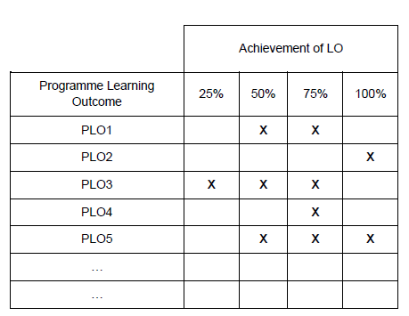

AUN-QA Criterion 2: Programme Structure and Content
2.1. The specifications of the program and all its courses are shown to be comprehensive, up-to-date, and made available and communicated to all stakeholders.

2.2 The design of the curriculum is shown to be constructively aligned with achieving the expected learning outcomes.

2.3 The design of the curriculum is shown to include feedback from stakeholders, especially external stakeholders.

2.4 The contribution made by each course in achieving the expected learning outcomes is shown to be clear.
2.5 The curriculum to show that all its courses are logically structured, properly sequenced (progression from basic to intermediate to specialised courses), and are integrated.

2.6 The curriculum to have option(s) for students to pursue major and/or minor specialisations.

2.7 The program to show that its curriculum is reviewed periodically following an established procedure and that it remains up-to-date and relevant to industry.

AUN-QA Criterion 3: Teaching and Learning Approach
3.1 The educational philosophy is shown to be articulated and communicated to all stakeholders. It is also shown to be reflected in the teaching and learning activities.

3.2 The teaching and learning activities are shown to allow students to participate responsibly in the learning process.

3.3 The teaching and learning activities are shown to involve active learning by the students.

3.4 The teaching and learning activities are shown to promote learning, learning how to learn, and instilling in students a commitment for life-long learning (e.g., commitment to critical inquiry, information-processing skills, and a willingness to experiment with new ideas and practices).

3.5 The teaching and learning activities are shown to inculcate in students, new ideas, creative thought, innovation, and an entrepreneurial mindset.

3.6 The teaching and learning processes are shown to be continuously improved to ensure their relevance to the needs of industry and are aligned to the expected learning outcomes.

AUN-QA Criterion 4: Student Assessment
4.1 A variety of assessment methods are shown to be used and are shown to be constructively aligned to achieving the expected learning outcomes and the teaching and learning objectives.

4.2 . The assessment and assessment-appeal policies are shown to be explicit, communicated to students, and applied consistently.

4.3 The assessment standards and procedures for student progression and degree completion, are shown to be explicit, communicated to students, and applied consistently.

4.4 The assessments methods are shown to include rubrics, marking schemes, timelines, and regulations, and these are shown to ensure validity, reliability, and fairness in assessment.

4.5 The assessment methods are shown to measure the achievement of the expected learning outcomes of the program and its courses.

4.6 Feedback of student assessment is shown to be provided in a timely manner.

4.7 The student assessment and its processes are shown to be continuously reviewed and improved to ensure their relevance to the needs of industry and alignment to the expected learning outcomes.

AUN-QA Criterion 5: Academic Staff
5.1 The program to show that academic staff planning (including succession, promotion, re-deployment, termination, and retirement plans) is carried out to ensure that the quality and quantity of the academic staff fulfil the needs for education, research, and service.

5.2 The program to show that staff workload is measured and monitored to improve the quality of education, research, and service
.
5.3 The program to show that the competences of the academic staff are determined, evaluated, and communicated.

5.4 The program to show that the duties allocated to the academic staff are appropriate to qualifications, experience, and aptitude.

5.5 The program to show that promotion of the academic staff is based on a merit system which accounts for teaching, research, and service.

5.6 The program to show that the rights and privileges, benefits, roles and relationships, and accountability of the academic staff, taking into account professional ethics and their academic freedom, are well defined and understood.

5.7 The program to show that the training and developmental needs of the academic staff are systematically identified, and that appropriate training and development activities are implemented to fulfil the identified needs.

5.8 The program to show that performance management including reward and recognition is implemented to assess academic staff teaching and research quality.

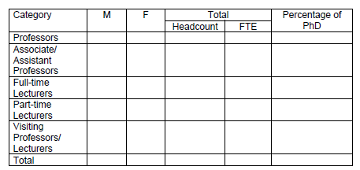

AUN-QA Criterion 6: Student Support Services
6.1 The student intake policy, admission criteria, and admission procedures to the program are shown to be clearly defined, communicated, published, and up-to-date.
กรุณาระบุข้อมูลเชิงปริมาณลงในตาราง โดยนำเสนอข้อมูลย้อนหลังไม่น้อยกว่า 3 ปี
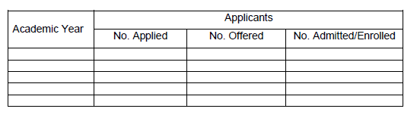
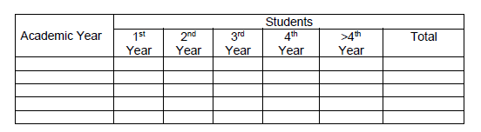

6.2 Both short-term and long-term planning of academic and non-academic support services are shown to be carried out to ensure sufficiency and quality of support services for teaching, research, and community service.
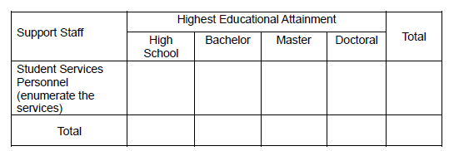

6.3 An adequate system is shown to exist for student progress, academic performance, and workload monitoring. Student progress, academic performance, and workload are shown to be systematically recorded and monitored. Feedback to students and corrective actions are made where necessary.

6.4 Co-curricular activities, student competition, and other student support services are shown to be available to improve learning experience and employability.

6.5 The competences of the support staff rendering student services are shown to be identified for recruitment and deployment. These competences are shown to be evaluated
to ensure their continued relevance to stakeholders needs. Roles and relationships are shown to be well-defined to ensure smooth delivery of the services.

6.6 Student support services are shown to be subjected to evaluation, benchmarking, and enhancement

AUN-QA Criterion 7: Facilities and Infrastructure
7.1 The physical resources to deliver the curriculum, including equipment, material, and information technology, are shown to be sufficient.

7.2 The laboratories and equipment are shown to be up-to-date, readily available, and effectively deployed.

7.3 A digital library is shown to be set-up, in keeping with progress in information and communication technology.

7.4 The information technology systems are shown to be set up to meet the needs of staff and students.

7.5 The university is shown to provide a highly accessible computer and network infrastructure that enables the campus community to fully exploit information technology for teaching, research, service, and administration.

7.6 The environmental, health, and safety standards and access for people with special needs are shown to be defined and implemented.

7.7 The university is shown to provide a physical, social, and psychological environment that is conducive for education, research, and personal well-being.

7.8 The competences of the support staff rendering services related to facilities are shown to be identified and evaluated to ensure that their skills remain relevant to stakeholder needs.

7.9 The quality of the facilities (library, laboratory, IT, and student services) are shown to be subjected to evaluation and enhancement.

AUN-QA Criterion 8: Output and Outcomes
กรุณากรอกข้อมูลลงในตารางตามคู่มือ AUN-QA โดยนำเสนอข้อมูลย้อนหลังตั้งแต่เปิดรับนิสิตหรือไม่น้อยกว่า 3 ปี
8.1 The pass rate, dropout rate, and average time to graduate are shown to be established, monitored, and benchmarked for improvement.
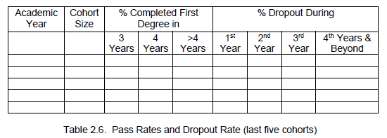

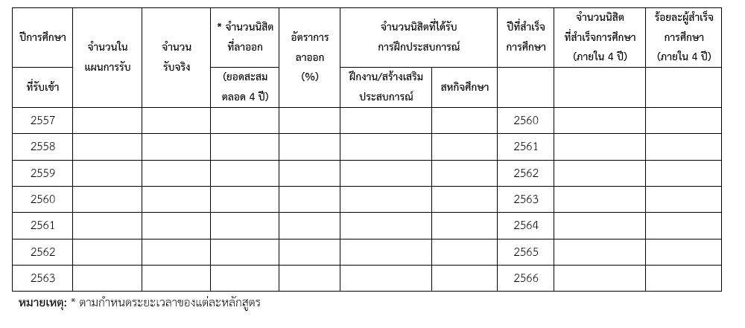

8.2 Employability as well as self-employment, entrepreneurship, and advancement to further studies, are shown to be established, monitored, and benchmarked for improvement.
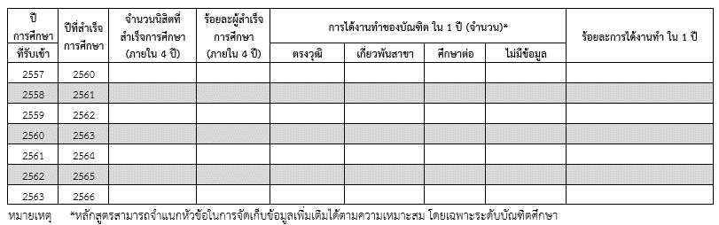
ตัวอย่าง
8.3 Research and creative work output and activities carried out by the academic staff and students, are shown to be established, monitored, and benchmarked for improvement.
กรุณาระบุข้อมูลเชิงปริมาณลงในตาราง โดยนำเสนอข้อมูลย้อนหลังตั้งแต่เปิดรับนิสิตหรือไม่น้อยกว่า 3 ปี
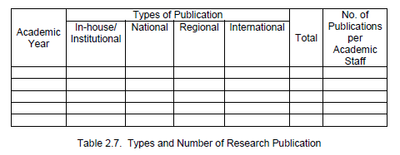

8.4 Data are provided to show directly the achievement of the program outcomes, which are established and monitored.

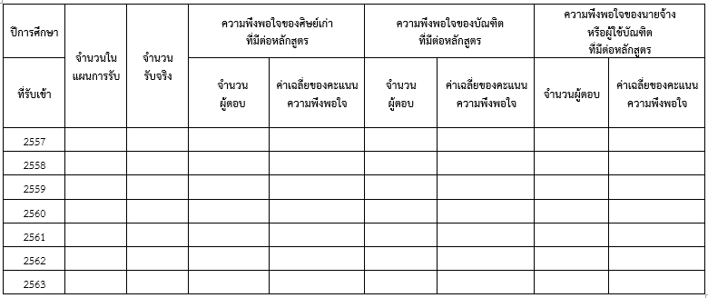
8.5 Satisfaction level of the various stakeholders are shown to be established, monitored, and benchmarked for improvement.

Part III - Strengths and weakness analyses
ให้หลักสูตรวิเคราะห์จุดแข็ง และ จุดอ่อน ของการดำเนินงานในปีการศึกษา................ ที่ผ่านมา และแนวทางการพัฒนาหลักสูตร ต่อไปในปีการศึกษาถัดไป

AUN-QA Criterion | Strength | Weakness | Area of improvement | ระยะเวลาที่ต้องแล้วเสร็จ
1. Expected Learning Outcomes
2. Programme Structure and Content
3. Teaching and Learning Approach
4. Student Assessment
5. Academic Staff
6. Student Support Services
7. Facilities and Infrastructure
8. Output and Outcomes

APPENDICES

